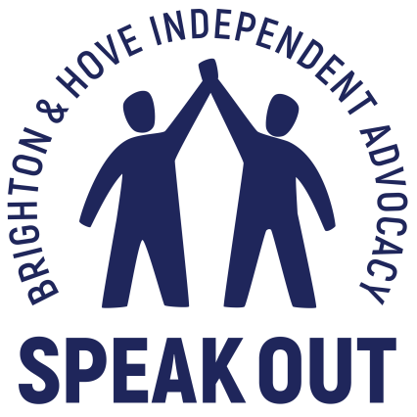

Relationships

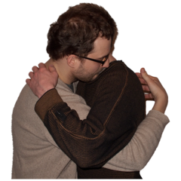

A consultation with people with learning disabilities

Brighton and Hove Speak Out
October 2019 – January 2020

Speak Out
Speak Out is an independent advocacy organisation working with adults with learning disabilities living in the Brighton and Hove area. We work with people in several ways including 1:1 issue advocacy, Self-advocacy groups and drop in services around the city. Our self-advocacy groups represent key demographics, such as young people, older people and an LGBTQ group. We also have a regular presence in day services, sheltered housing, residential homes and supported living throughout Brighton and Hove. We continue to explore new ways of engaging hard to reach and marginalised individuals whose views often go unexpressed.
This report:
From July 2019 – October 2019 Brighton and Hove Speak Out conducted a consultation with people with learning disabilities to find out what they see as the biggest issues facing them in their lives. This consultation was contracted by Brighton and Hove City Council to inform the formulation of a new Learning Disability Strategy. The majority of those interviewed said that the opportunity and support to have relationships was the foremost concern in their lives.
This report will explore the factors that stand in the way of people with learning disabilities having relationships. It will also identify emerging trends such as online safety, social media and pornography. Another area that demands more focus is coercive control and abusive relationships.
Methodology:
During the consultation period October 2019 until January 2020 Speak Out consulted 23 people with learning disabilities around the city.
- Individual private interviews
- 1 older persons focus group
- 1 younger persons focus group
- Drop in attendees
- 3 ‘pop up’ drop ins: Team Domenica, Patching Lodge, St John’s
- Day service users at Grace Eyre
All interviews were face to face in locations chosen by interviewees. Discussion consisted of set questions to prompt exploration of personal experiences and views.
In addition, we were able to draw on a body of work based on the views of people with learning disabilities around issues such as Employment and volunteering, wellbeing, Health Improvement services, and access to activities and information.

Demographic:
All participants were residents of Brighton and Hove and between the ages of 16 and 85.

Locally
Adults and young people in Brighton and Hove have told us that the biggest issue facing them is their ability to form and maintain healthy relationships of all types.
The social landscape for people with learning disabilities has changed considerably in the last ten years. Previously many people sustained friendships and relationships with their peers through a number of day services around the city. However in recent years the majority of day services have closed and the number of people receiving services has been reduced. The result of these changes is that people with learning disabilities say they are more vulnerable to loneliness and marginalisation.
In addition to this Brighton and Hove has been identified as having one of the highest rates of loneliness in the country. These factors not only affect people’s mental health and wellbeing, but also leave them more vulnerable to abuse and unhealthy relationships.

Nationally

‘Loneliness is associated with physical and mental health problems and poorer quality of life.’ (Gilmore & Cuskelly, 2014).
The effects of loneliness and isolation on health and wellbeing are well documented:
- Loneliness, living alone and poor social connections are as bad for your health as smoking 15 cigarettes a day.
- Loneliness has a more negative effect on health than obesity and is likely to increase risk of death by 29%
- Lonely people are more likely to suffer from dementia, heart disease and depression.
People with learning disabilities tell us that they experience levels of loneliness and isolation that have a negative impact on their health and wellbeing. In a recent survey of people with a learning disability, Mencap found that “24% said they felt lonely ‘a lot’. This compares to just 3.4% of the general population who said they felt lonely ‘often or always.”
There have been advances in the rights of people with learning disabilities in recent years. They are experiencing more choices and opportunities than they have done historically. However, young people with learning disabilities are facing a loneliness epidemic.
Research suggests that 1 in 3 young people with a learning disability spend less than 1 hour outside their home on a typical Saturday (Mencap, 2019).
In a survey by Sense, over half of disabled people reported feeling lonely, rising to over three quarters (77%) for those aged 18-34 (Sense 2017).
Community

People with learning disabilities would like to be part of their local community, but say it is beyond their reach. Many feel nervous of the reception they receive when they go out. They say there is still a lack of understanding about learning disabilities. This means that they are often met with impatience, rudeness, and sometimes even name-calling. Those who live independently told us they struggle to navigate day to day life and social interaction without support.

Other issues that prevent people being part of a community, attending events and activities include:

- Lack of accessible information
- Inaccessible venues
- Lack of inclusive activities
- Financial restrictions
- Insufficient support

- People want to join in and be part of their community
- They feel left out and alone
- They say people don’t understand learning disabilities
- They do not get enough support or money to do the things they would like

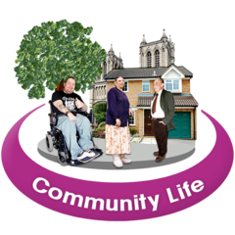

Spending time with others

Maintaining friendships has proved difficult for those people who are no longer eligible for a day service. The majority of those who attended in the past now need support to go out and meet up with their peers.
Those who are more independent face a different set of barriers to making friends and seeing people. Support needs and living situations present varying obstacles to meaningful relationships and connections.

Residential care homes
Some people in residential care no longer receive a day service. This means that they lose well-established friendships formed over many years, often since school. Most people we speak to in residential care say that they are reliant on support staff to go out.

‘I have to wait for staff to take me everywhere. It hasn’t been easy for me at all. Because of my age, it is really hard. They say sorry you can’t go out because we are short of staff.’
In recent years, some residential services have sold the communal vehicles that were at the disposal of residents for weekend outings and attending activities and day services. Many people now have to pay for individual taxis, the cost of which can be prohibitive.

“I don’t get to go anywhere at weekends. I’m just stuck indoors.’

Living Independently
Despite having the skills to go out alone people who live independently report the highest levels of loneliness and isolation. There are many issues that add to feelings of marginalisation and isolation:

- No access to education or training
- No opportunity to access work or volunteering
- No support with anxiety or mental health problems
- No support to try new activities
- Lack of low cost inclusive activities
- Difficulty understanding information
- Nowhere to meet new people

‘I don’t do anything all week. I just go to Speak Out (drop in). Without that I wouldn’t have anything to do.’

‘I’d like to try some new things. But I can’t go on my own. I get too scared. What if they don’t understand? I need someone to come with me a few times so I know how it all works.’

Living with family
K is 26 years old and lives with her family. Her parents both work full time. She has a history of mental and anxiety for which she takes medication. Although she has been deemed ineligible for any assistance she has been supported by the Supported Employment Team to find volunteer positions. These placements have broken down due to employers not fully understanding the level of ongoing support needed.
This has left K spending most of her time alone in the house while her family are at work.

‘I don’t like asking my family for everything. I haven’t got anyone else to ask. I want to be more independent, but I need to learn new skills. What about if my family weren’t around? I feel very lonely. I want to do things and meet people. It’s too hard. There’s no space for me. I feel very low.’

Supported living
B lives in their own flat in a supported scheme; she receives support to go out in the community. Her current accommodation gives her a feeling of independence and freedom
She used to live in a group home and attend a day service. Although her living situation is much improved, she misses her friends many of whom access a day service through Grace Eyre. She spends most of her time with support workers and feels she has no friends where she lives or in the community.

‘I’ve got my own space now. But I miss Belgrave; I miss my friends. I went on Monday Tuesday and Wednesday. We used to go out in the minibus.’
‘I’ve got my own space but I miss my friends. I’ve told carers I miss my friends’

      - People say life is lonely without a day service

      - They miss their friends

      - They feel ‘stuck indoors

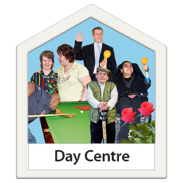

Relationships and dating

Only 3% of people with a learning disability live as a couple, compared to 70% of the general adult population.
The majority of people we spoke to want to be in a romantic relationship. People expressed a number of frustrations:

- Not having social opportunities to meet potential partners
- Not having their relationship facilitated by those who support them
- Feeling fobbed off when they bring up the subject of relationships
- Not being “allowed” to have a partner.
- Not having the opportunity to explore and talk about relationships

‘I would like to meet someone. I would like to go on dates. I’d like to find out more about heart venture, I’ve told my carer.’

‘I want to go out for a meal with my girlfriend. We see each other at Grace Eyre. Someone would have to come with us. We want to go on a date.’

‘I live at home. I would like to see my boyfriend more. He works during the week. I don’t see him much. We don’t live near each other.’

Often those who have partners say they are only able to see them if family/support/carers facilitate it.

M lives with his mother, attends a day service and has a girlfriend:
‘I want her to come for a meal. My mum says that she can come here. My girlfriend lives in residential. She has to come with support. There is not enough support so she can’t come. I am very disappointed.’

B met his girlfriend at a day service. They see each other there a couple of times a week.

“We are girlfriend and boyfriend. We want to go out for a meal. My brother will drive me. She (girlfriend) lives in shared lives. They will not bring her. She is not allowed by herself.’

F has profound and multiple disabilities, he is non-verbal and communicates with movement. He has limited mobility and has 24 hour support in his supported living flat.
‘Where I was before no one took the time to communicate with me. Now I’m in supported living staff are more interested in what I want and what I’m interested in. I got very low because I have always wanted a family of my own but I didn’t think I could have one. I really needed to talk about it. I really needed to talk about relationships too. These things are important. We are the same as everyone else. It’s easy not to listen or ignore it. It’s not fair.’

- People say they would like to meet a partner but it is hard
- They would like the chance to talk about it and get support.
- It is hard for people to spend time with their partners
- People want to have their relationships respected

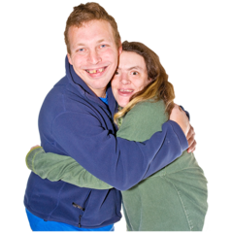

Information
Sometimes people are not sure what to do if someone they support would like to start dating or meet someone. The balance between risk and rights for people with a learning disability engaging in intimate or sexual relationships is often biased towards restricting their choices, both within family settings and other living arrangements.
Good accessible information about relationships, sex, sexuality and gender identity are essential. People with learning disabilities tell us that no one spoke to them about these issues until a problem arose. Information and support to help people with a learning disability to understand their sexuality and have relationships is lacking within many learning disability services.
Research suggests that children and adults with a learning disability are at a higher risk of sexual abuse than their non-disabled peers. The sexual safety of people with a learning disability is usually better protected when their sexuality is recognised by learning disability services
If information and support is given, it may be provided in an unplanned way, be insufficient or inappropriate for people with a learning disability. As a result, people with a learning disability often hold incomplete or inaccurate knowledge of relationships (including LGBTQ relationships), sexual health and the legal and emotional aspects of sex.As a they are at higher risk of negative sexual experiences, contracting sexually transmitted infections or unwanted pregnancies.
Parents and carers say that the young people they support have a more fluid idea of gender and sexuality than the general population. It is also a fact that the experience of being transgender is more common in people with Asperger’s and autism. Parents tell us that they do not know how to support young people in discussing and exploring sex, sexuality and gender.
- There are lots of things people are confused about
- People want to talk about gender and sexuality
- They want to be supported to understand and talk about it
- They want easy read information about sex

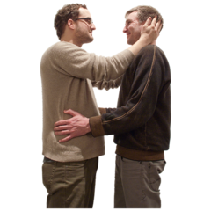

Online safety, social media
Social media and internet use continues to rise among people with learning disabilities. Assistive technologies mean that young people are able to navigate online platforms despite not having the literacy levels previously needed to do so. This gives rise to potential issues as the number of young people who grow up ‘digital natives’ increases.
- Online grooming and abuse of vulnerable and isolated people
- Parents do not know how to have conversations about online pornography
- People may share images or information about themselves that may leave them open to online abuse or blackmail
- People may themselves engage in online bullying or abuse
- It is hard to understand that anything posted online can be accessed by anyone at anytime

Child Protection cases
Parents with learning disabilities are more likely to have a child removed from their care than the rest of the population. Child protection processes often require parents do not post pictures of children on their social media accounts. Some people with learning disabilities have trouble understanding how their digital footprint can be captured by ex-partners and family courts and how serious the outcomes can be.
These cases can be particularly problematic when there is a history of abuse in the parents’ relationship. Speak Out has experience of supporting a parent through child protection proceedings. Part of their agreement barred them from posting pictures of their child on social media. The ex-partner was still exerting coercive control over the parent: convincing them it was ok to post photographs of the child on social media as no one would find out. The ex-partner then reported the activity to social services in order to jeopardise the parent’s custody of their child.

- Lots of people with learning disabilities use the internet

- People need to know what is safe behaviour online

- People need to understand who can see the things they post.

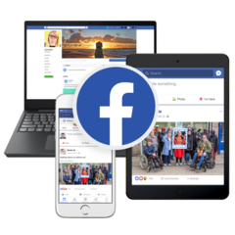

Healthy relationships
Rates of domestic abuse reported by people with disabilities are more than double those of the rest of the population.

- 16% of women with a long-term illness or disability had experienced domestic abuse compared to 6.8% of non-disabled women.

- 8% of men with a long-term illness or disability had experienced domestic abuse compared to 3.2% of non-disabled men.

Victims with a disability were more likely to experience other effects as a result of their abuse, including mental or emotional problems, difficulty in other relationships and attempted suicide.

People with learning disabilities have told us that they feel ‘grateful’ if someone shows an interest in them. At first people feel less lonely and isolated in a relationship. However as they come to ‘rely’ on the partner they are often cut off from friends, family and support services. There is also a strong chance that they are subjected to financial and economic abuse. This can lead them to stay with a partner who is abusing them.

‘He said ‘well, who else would want you? Who will help you if I’m not here? You would never manage without me.’’

There is now a greater understanding of the role coercive control plays in abusive relationships. Signs are difficult to spot at the beginning of a relationship and abusive patterns become normalised over time.

Two people told us that they were not aware they were in an abusive relationship until it was too late. Both said that they had never had conversations about warning signs or what constitutes a healthy relationship.

‘At first they were nice. But then I felt stupid. They said ‘you are stupid’. And when they were drunk I had to call the police. You feel stupid because then you let it happen. They are nice and you go back.’

People with learning disabilities can also be perpetrators of domestic abuse. Speak Out often support families for whom abusive relationships have been the norm over generations. The cycle continues the same way in friendships: those who have been the victim of ‘mate crime’ have gone on to financially abuse their peers.

- People want to learn about healthy relationships when they are younger
- They want to understand what is good and what is bad in a relationship
- They need to know who they can talk to if they are worried.

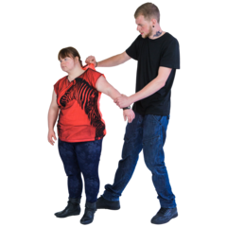

Recommendations

CCG, Public Health and Council to focus attention on the benefits of social prescribing and community navigators for people with learning disabilities. This work is currently being done by Together Co and GP surgeries

More sharing of up to date information about gender, sex and sexuality. There are links to easy read materials on the SHAC website. This needs to be widely publicized to providers, parents and carers.

Speak Out will be working with Rise to update their easy read information. This can be used to support people with learning disabilities to understand more about healthy relationships.

The Sexual Health and Contraception service (working in partnership with Speak Out’s Link group and the Health Facilitator) are launching a more accessible service for people with learning disabilities. An easy read web page has already been launched.

Schools, colleges and services for young people to address gender identity, sexuality and online safety as a matter of course.

The Health Facilitator (In partnership with a member of Speak Out’s link Group) will be reviewing the council Relationships Policy. This will provide a clear protocol to supporting people with learning disabilities around relationship issues.

Transition age pod to investigate how much information and support is available to young people and their parents and carers around gender, sex and sexuality.

Council, Public Health to identify professional whose role it is to advise around issues of gender, sex and sexuality.

